“NANHI UDAAN”
NEWSLETTER (2020-21)

Contact Number:-0181-2670800 FAX-0181-2670800
Website: - suranussi.kvs.ac.in

K.V. SURANUSSI,
JALANDHAR

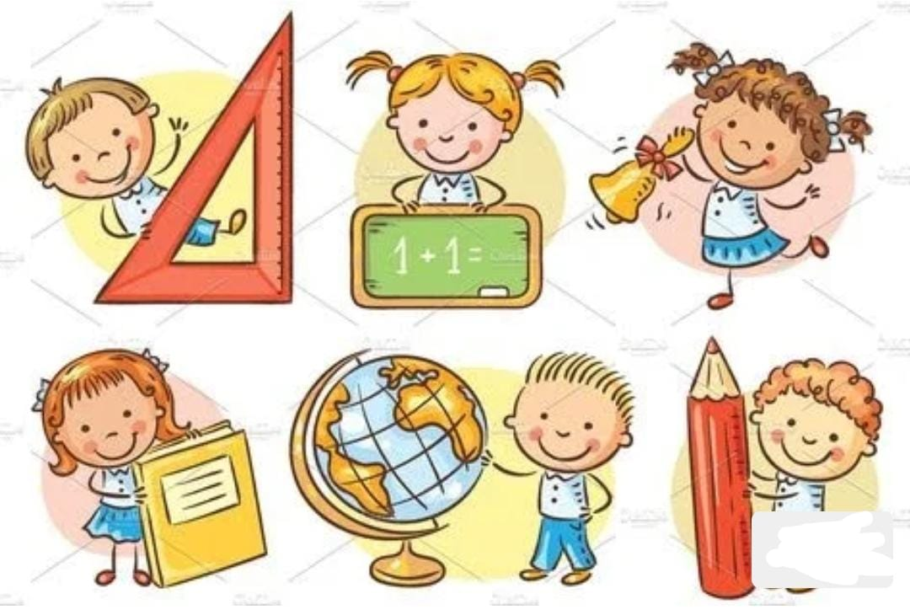

CHIEF patron

Mr. omprakash

(vicePrincipal)

Patronccaincharge& EDITOReditor

SMt.Sukhvinderkaur ms. Sangeeta ms.Kamaljitkaur

Senior most prt primary teacher primary teacher

Captains of different houses

Shivaji house

GEETANSH SHARMAV B
TANIKA Iv A

Tagore house

ANMOLDEEP SINGH VC
RUTH Iv B

Ashoka house

JASMEET SINGH v c
CHETAN v c

Raman house
YUVRAJ THANDIRA v C
YUVRAJ THAPAR Iv b

PRINCIPAL’S MESSAGE

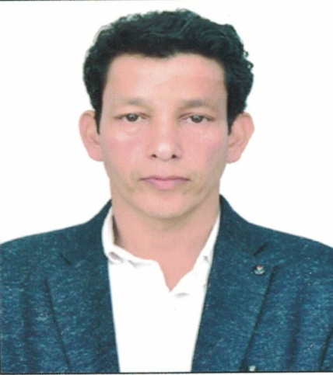

Mr.OM PRAKASH

(VICE PRINCIPAL)

As the Vice-Principal of the school, I feel honored and privileged to be a part of an educational institutionwhere every stakeholder is a learner and every day is an opportunity to learn and discover. We look at ourselves as a community of learners, where everyone learns including our teachers, parents and staff.
I believe in upholding high standards with an absolute commitment to strive to understand an improve the educational process, using team strategies, while wholly centering on students achievements.
message from senior most PRT
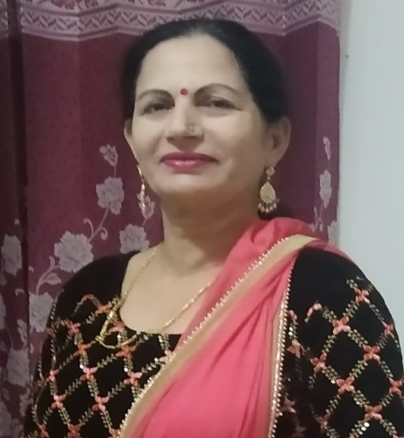
Mrs.SUKHVINDER KAUR
  - Welcome to the Newsletter of our school. The session started in the midst of an unprecedented situation with nation-wide lockdown due to the Covid –19 Pandemic .
  - Extraordinary situation demands extraordinary measures. Under the able guidance of worthy Vice Principal,Mr.Om Parkash Kashyap and the whole hearted support of all the teachers, all the activities could be conducted smoothly through online media .The students and parents co-operated with the school. The CMP newsletter showcases the activities conducted during the 1st term (April to September). The little hands of our students proved that they can do wonders even in the lockdown.
  - I would like to express my heartfelt thanks to Respected Vice- Principal Sir for his constant support, all my team members for their dedicated endeavours. I thank our students and their parents for supporting us at every step and enthusiastically taking part in all the activities.
  - I wish and pray for their health and safety.
KENDRIYA VIDYALAYA SURANUSSI
(JALANDHAR)

CCA CALENDAR (PRIMARY) 2020-21

DATE | ACTIVITY
08.08.2020 | meeting with primary teachers
22.8.2020 | Rakhi making
29.08.2020 | Best out of waste
05.09.2020 | English calligraphy
19.09.2020 | Hindi calligraphy
19.09.2020 | Hindi poem recitation
26.09.2020 | Solo song competition
26.09.2020 | Hindi slogan writing
01.10.2020 | Grand parents day celebration
31.10.2020 | English poem recitation
07.11.2020 | Kitchen gardening
28.11.2020 | Story telling competition
05.12.2020 | Fancy dress competition

RESULT OF
CO-CURRICULAR ACTIVITIES
(2020-21)

 | ENGLISH CALLIGRAPHY
I | AGAMJOT SINGH | III B
II | ANURAG | V C
III | RIYA | IV B

 | SOLO SONG COMPETITION
I | GEETANSH | V B
II | RANBIR | V A
III | RUPALI | III C

 | RAKHI MAKING
I | SANDEEP MAHAY | V C
II | JASMEET SINGH (1) | V C
III | SKAINA | V C
 | BEST OUT OF WASTE
I | MANVI | III C
II | NAVNEETA BISHT | III C
III | ERA THAKUR | III C

 | HINDI POEM RECITATION
I | TEHANA | II B
II | EKAMPREET | V A
III | ROHIT | IV C

 | HINDI CALLIGRAPHY
I | GEETANSH SHARMA | V B
II | MUSKAN | II A
III | MANSHA | V A

 | HINDI SLOGAN WRITTING
I | ARSHPREET KAUR | IV B
II | SEERAT | II B
III | RANBIR | V A

RakhiMAKING

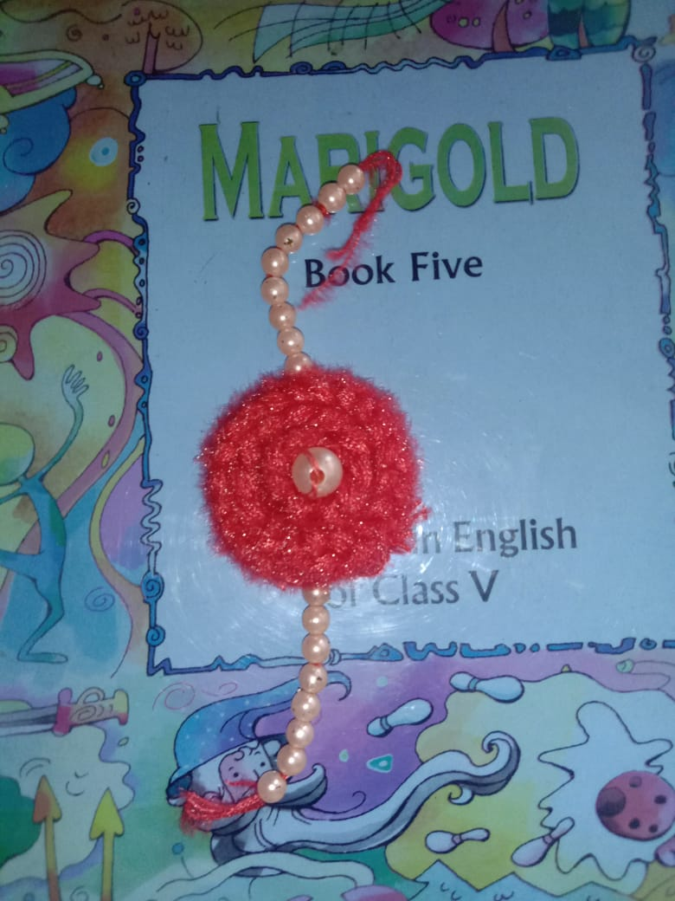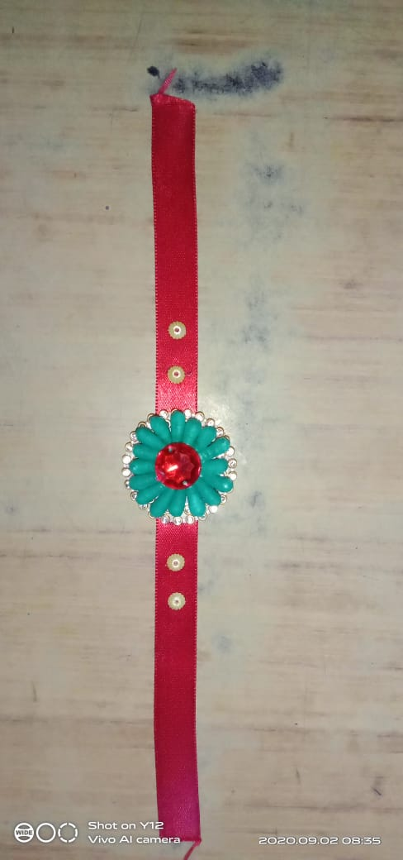

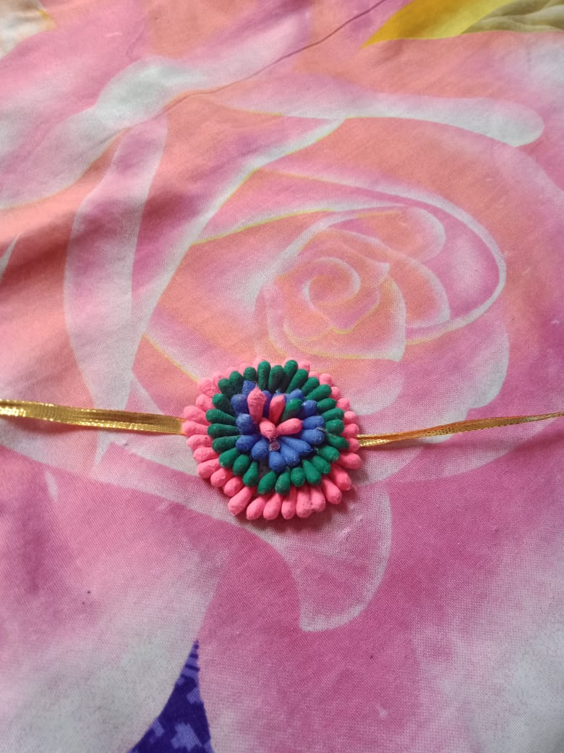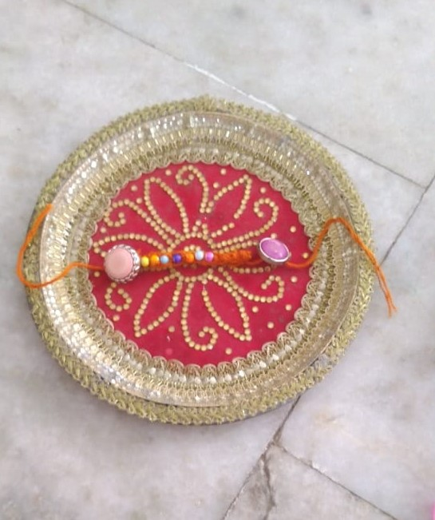

BEST OUT OF WASTE

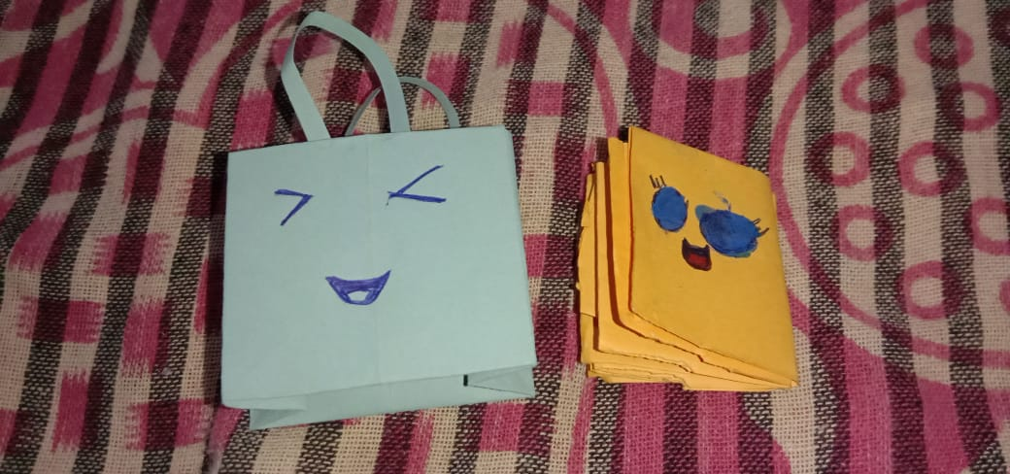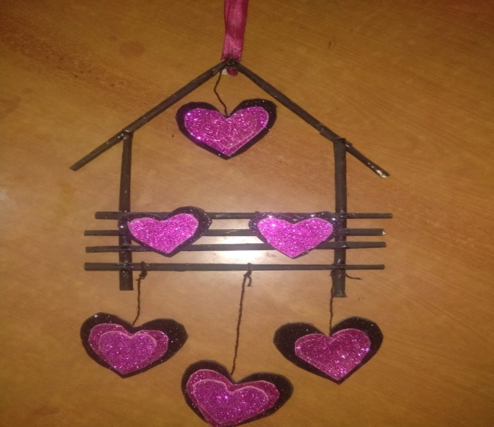

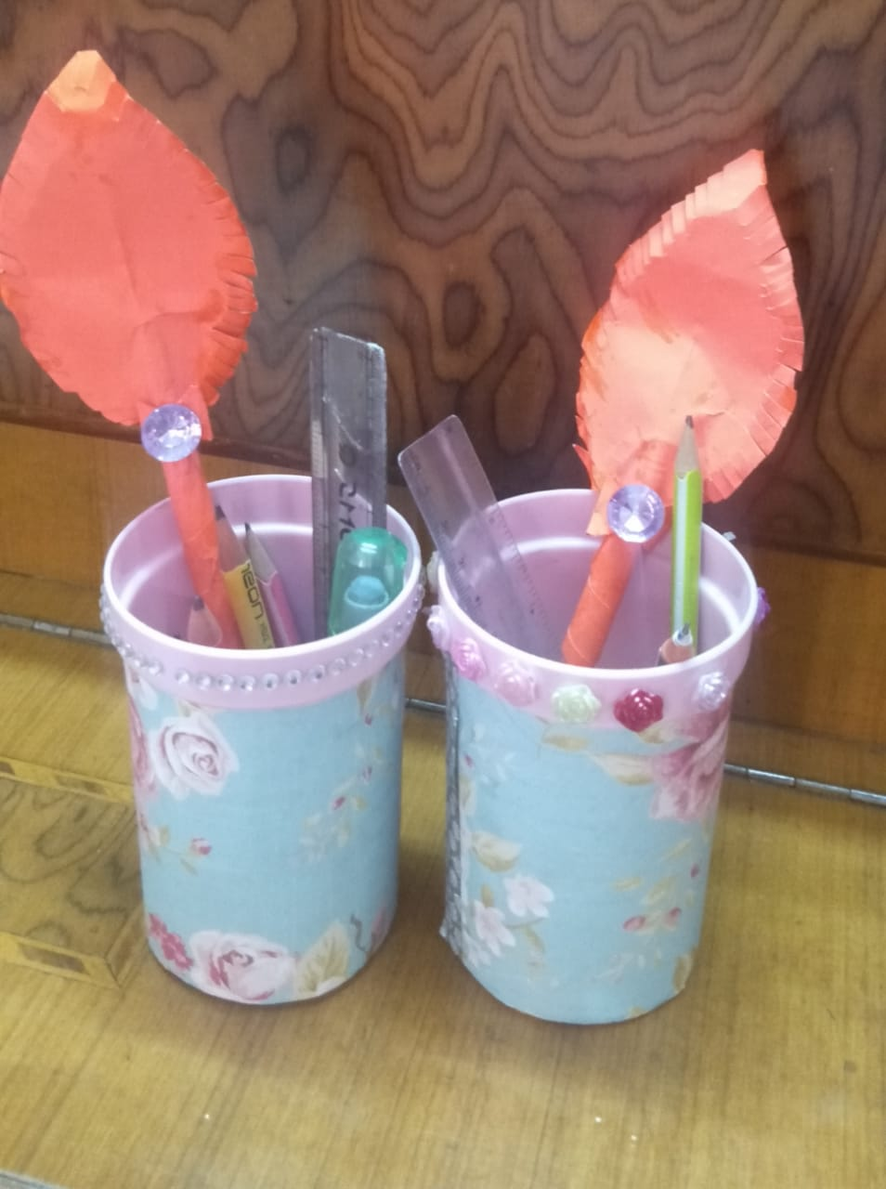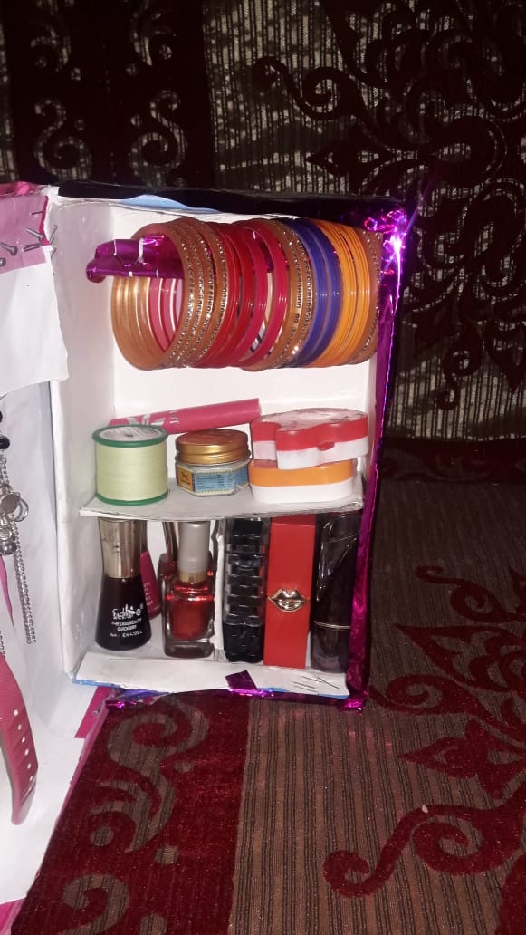

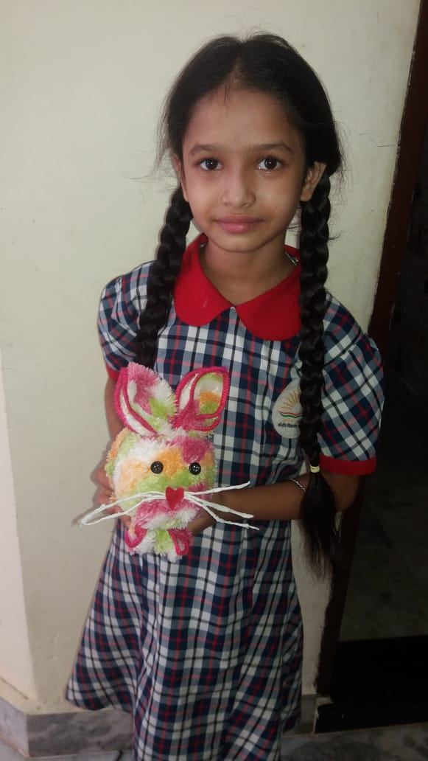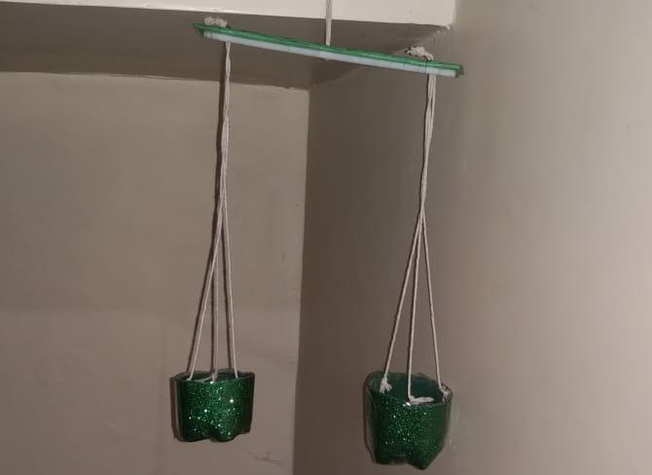
HINDI POEM RECITATION

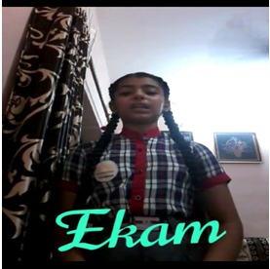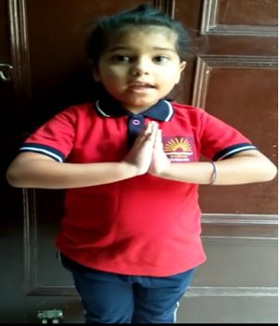

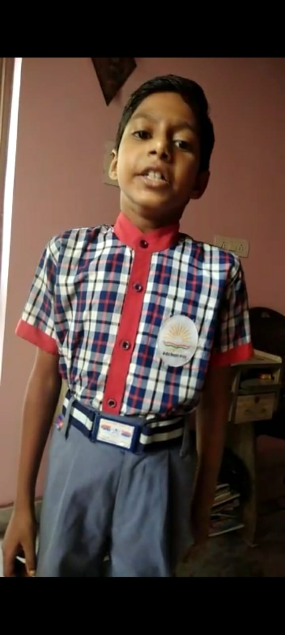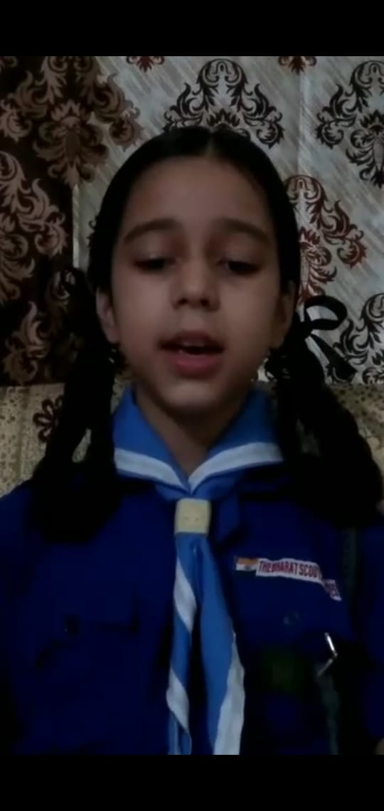
SOLO SONG COMPETITION

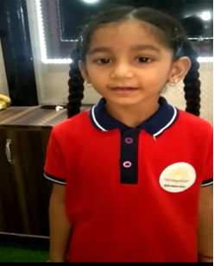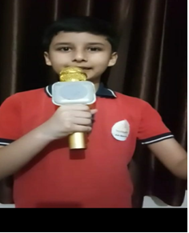

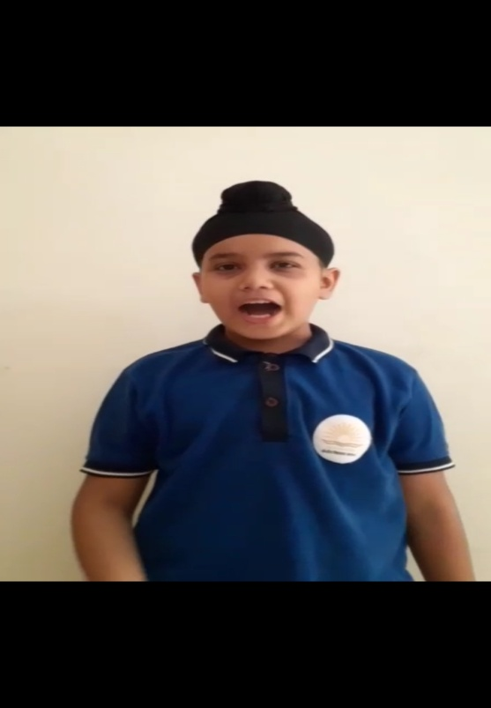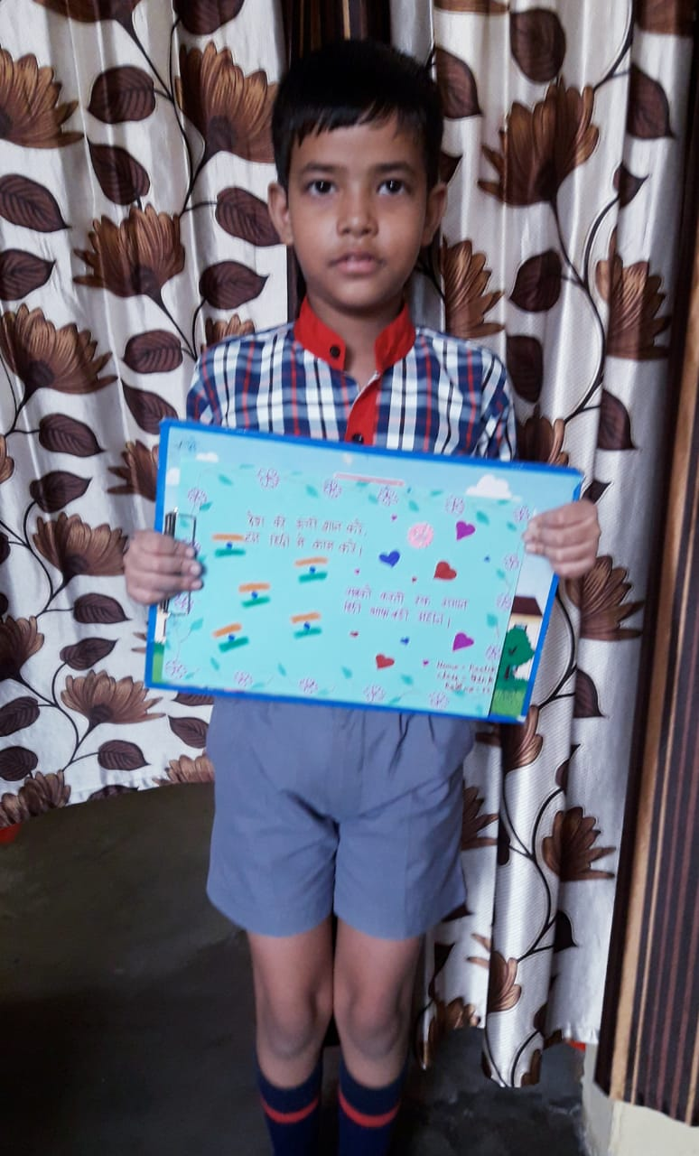
HINDI SLOGAN WRITTING

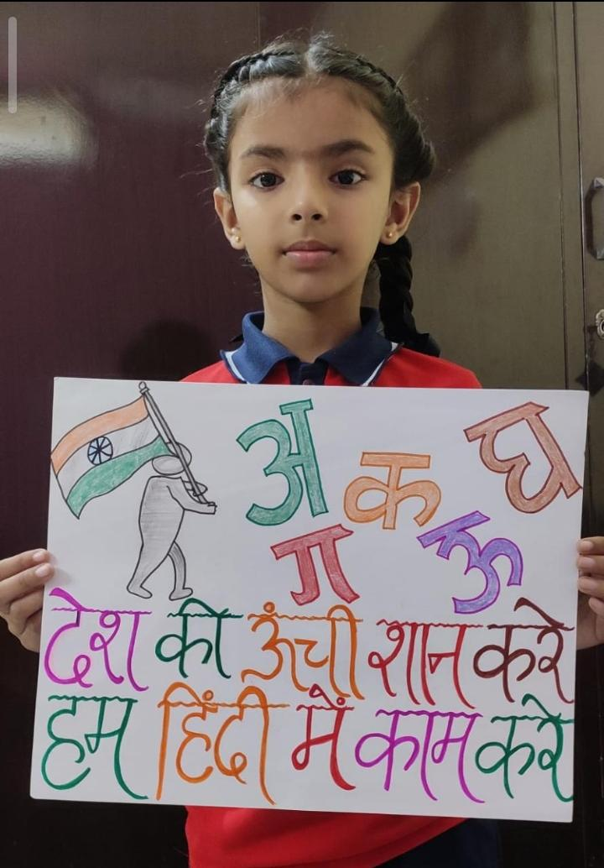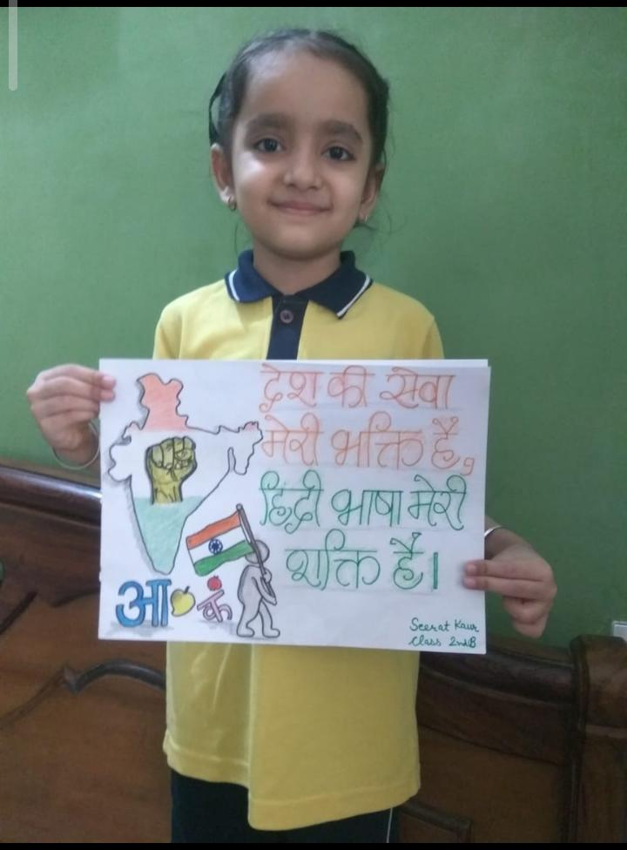

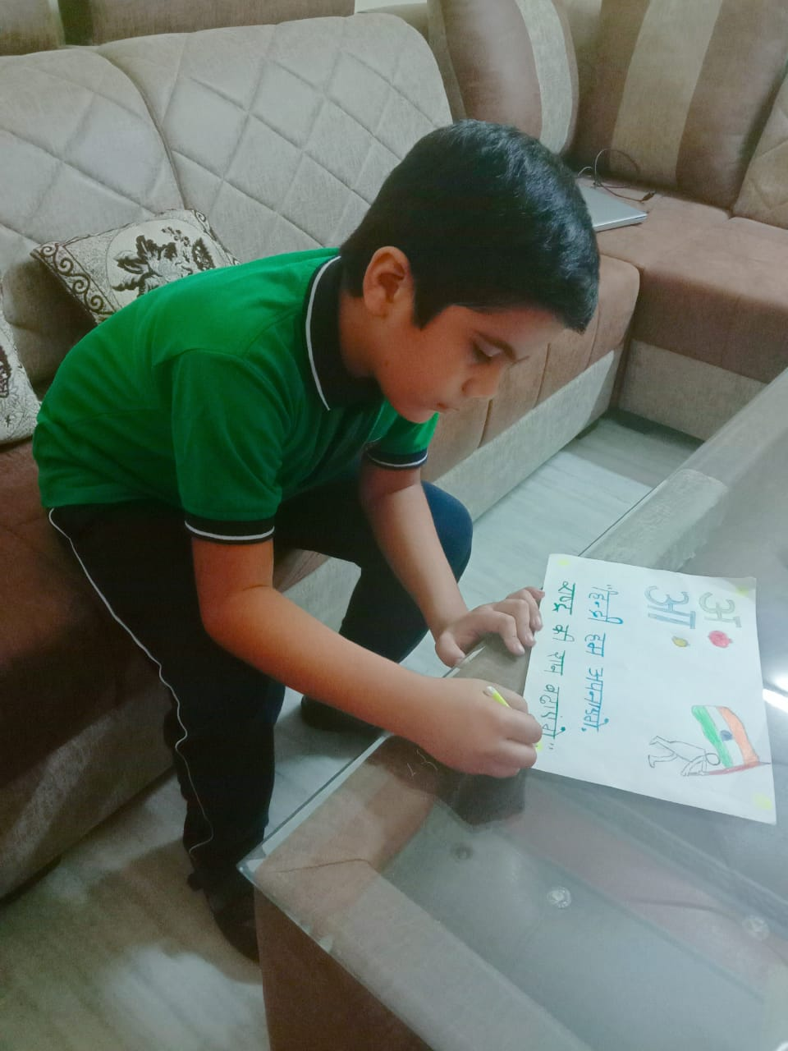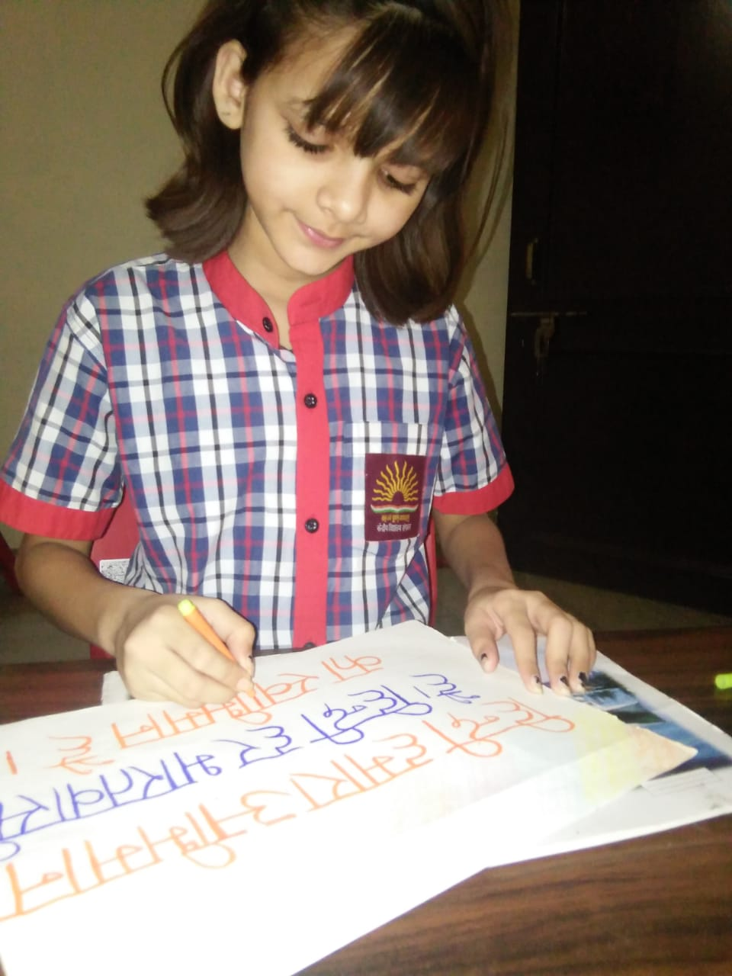

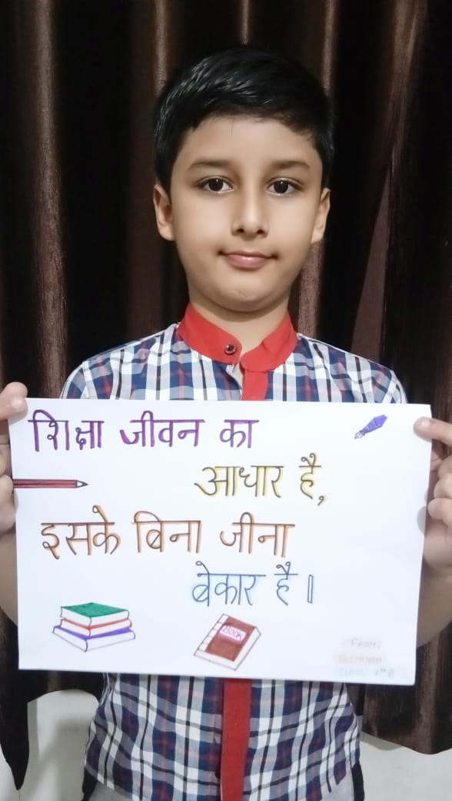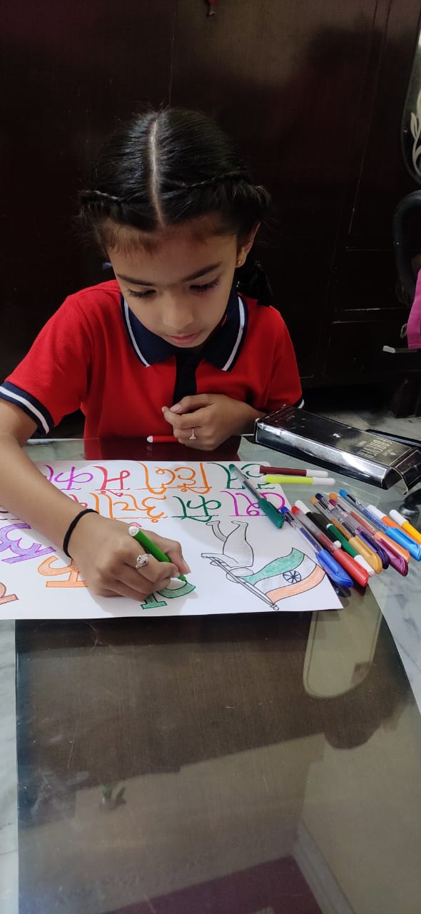
KITCHEN GARDEN

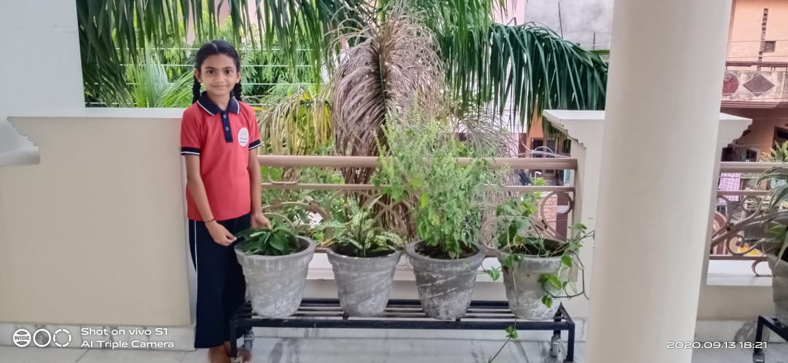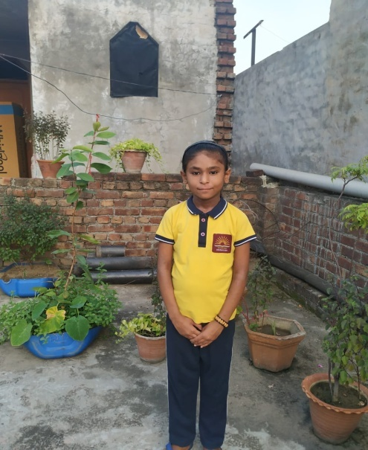

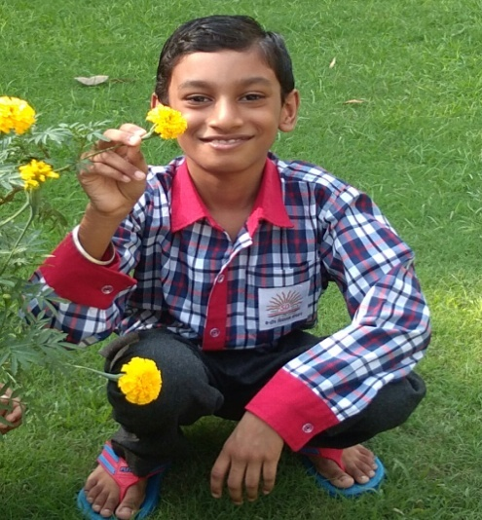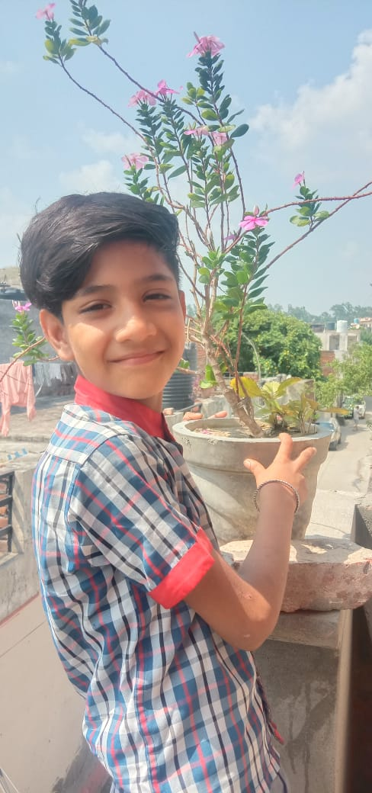

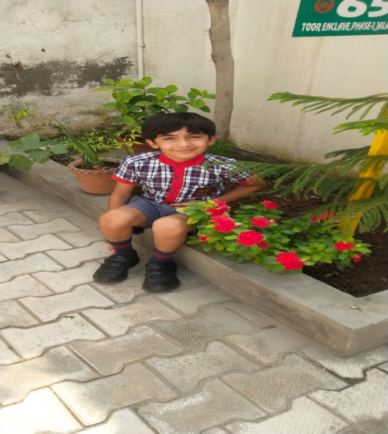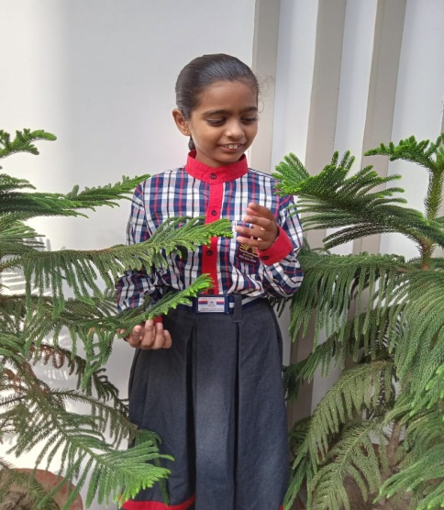
ENGLISH SLOGAN WRITING

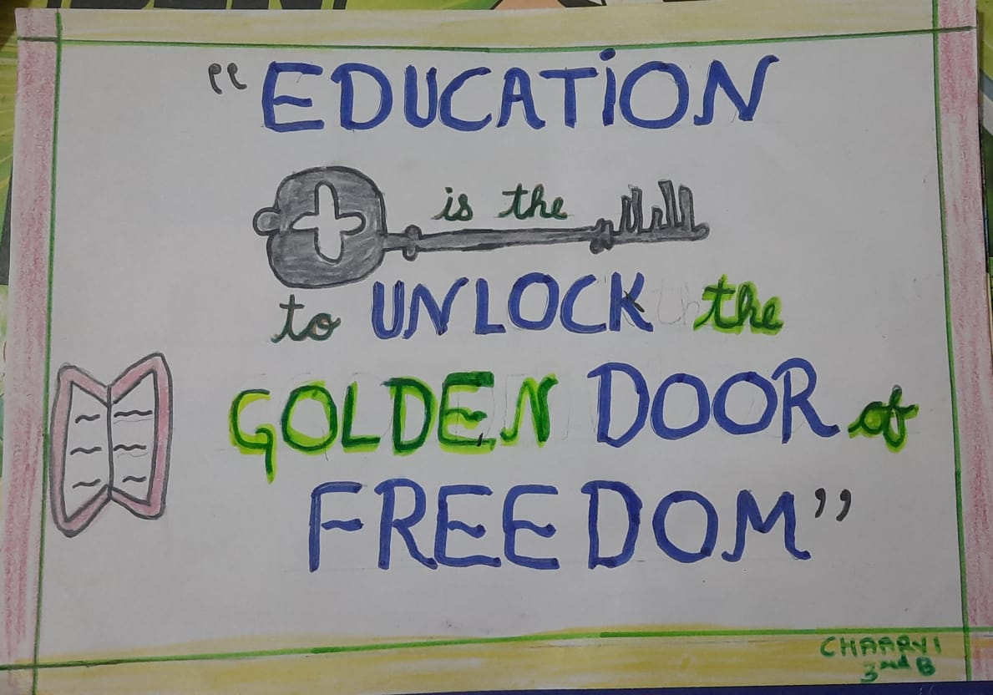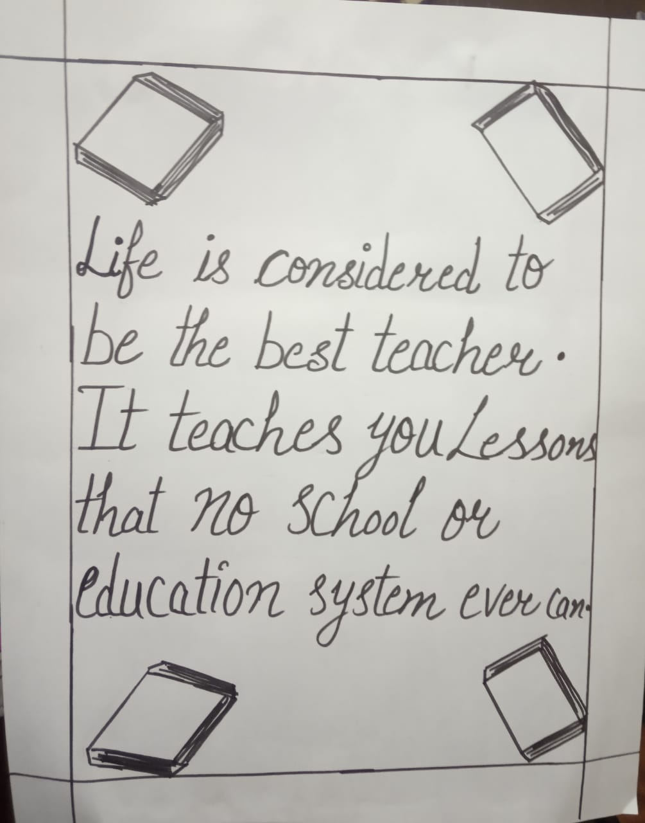

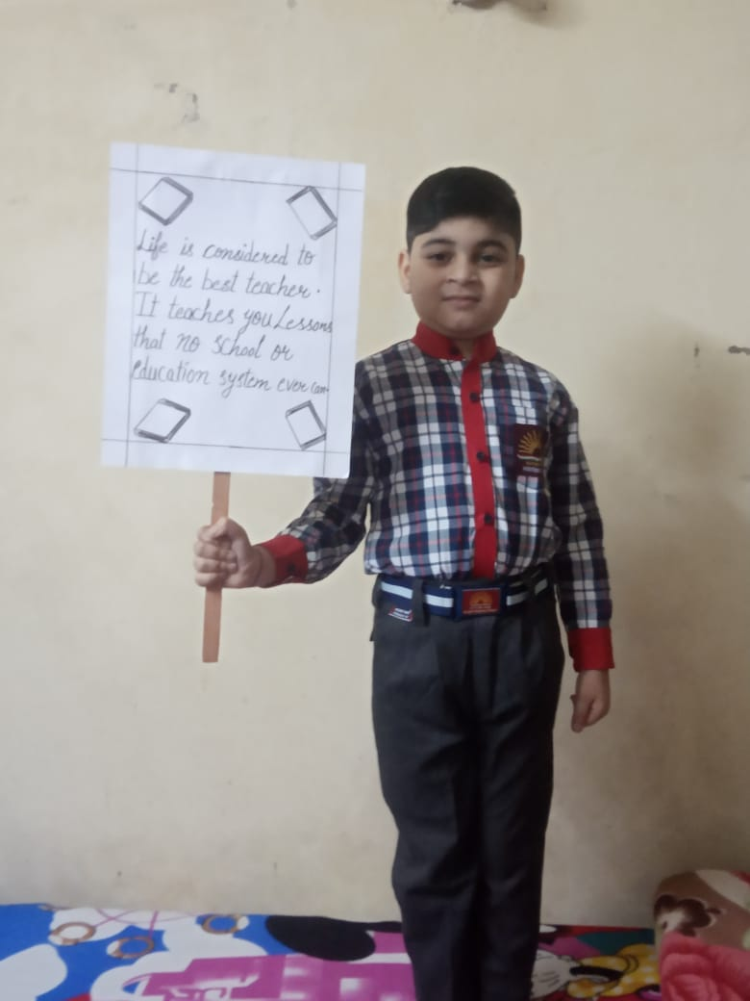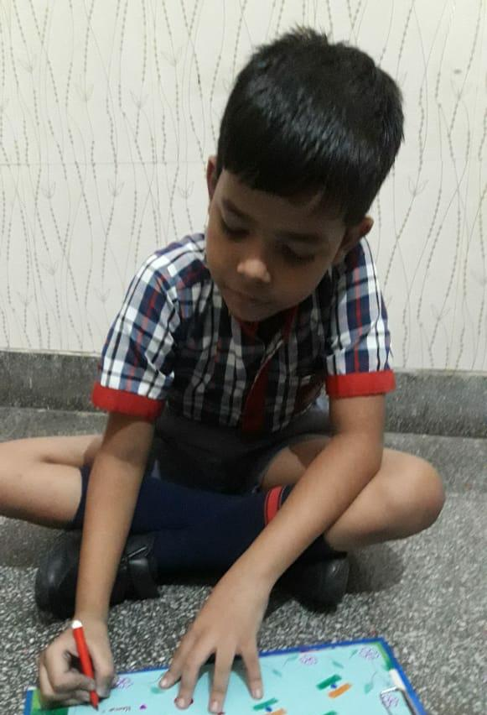
FUNDAY ACTIVITIES

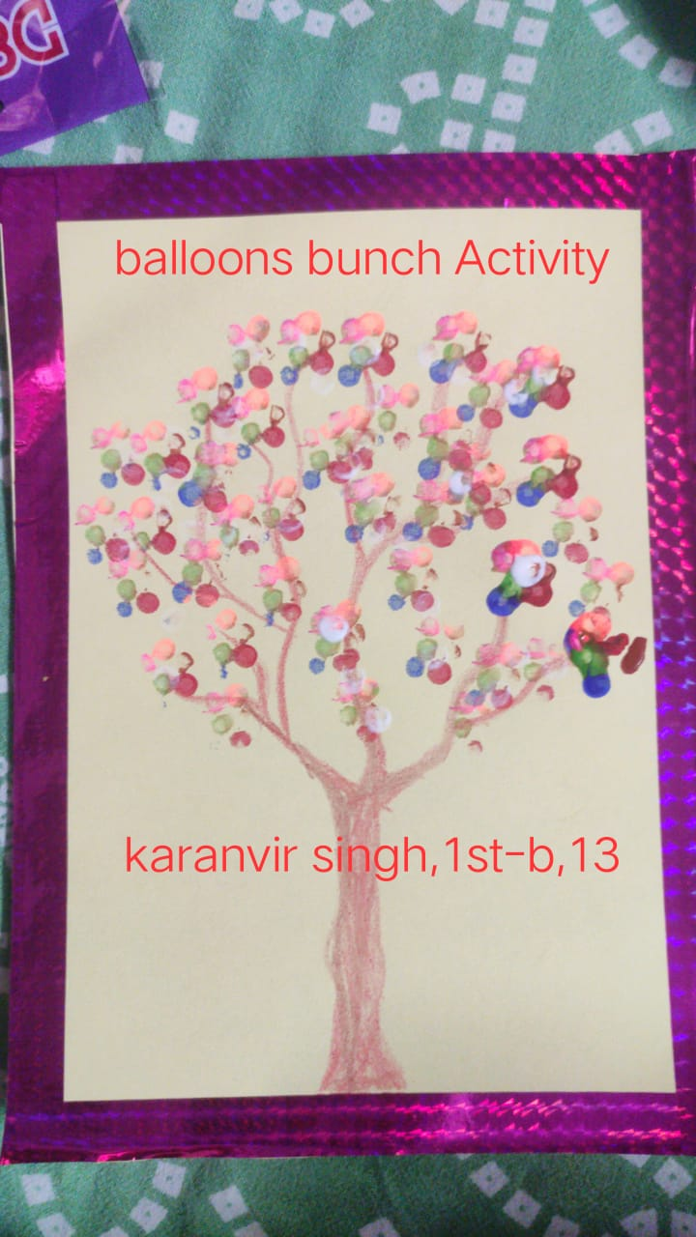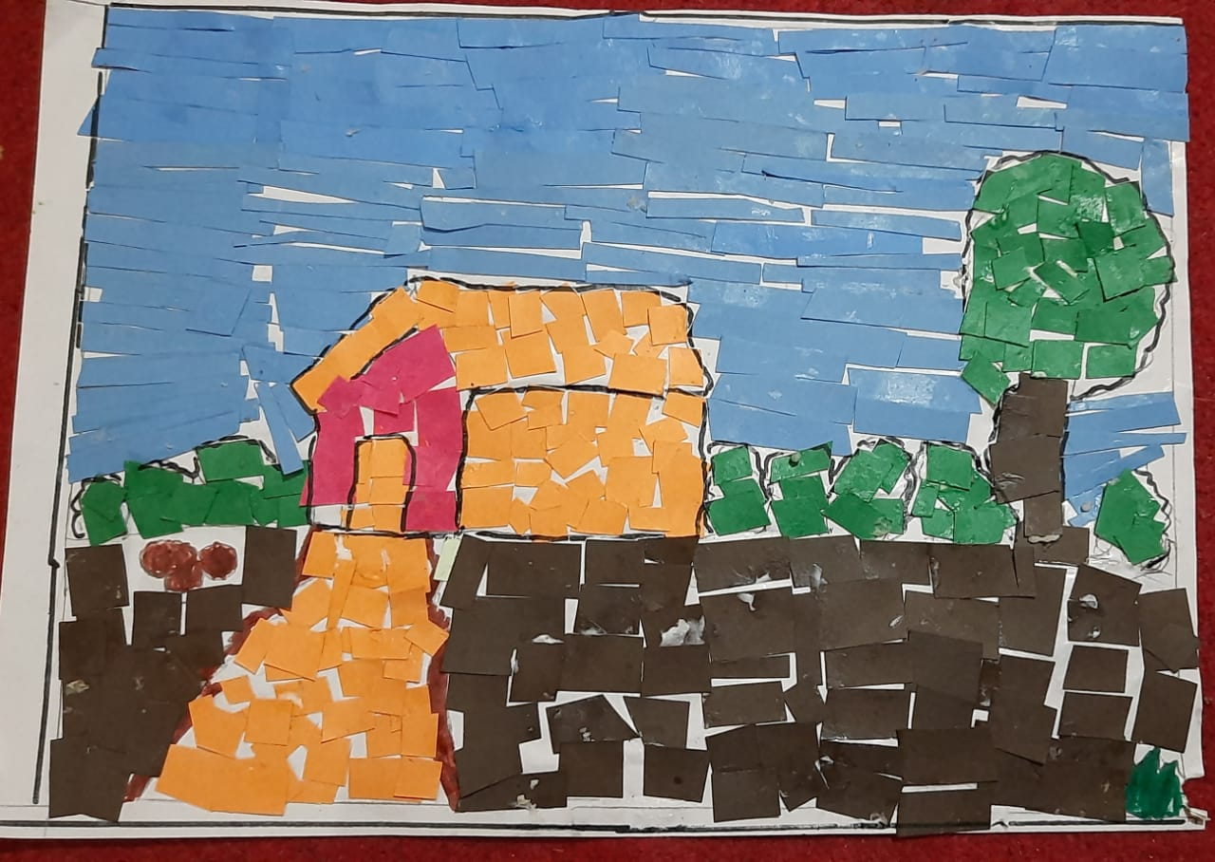

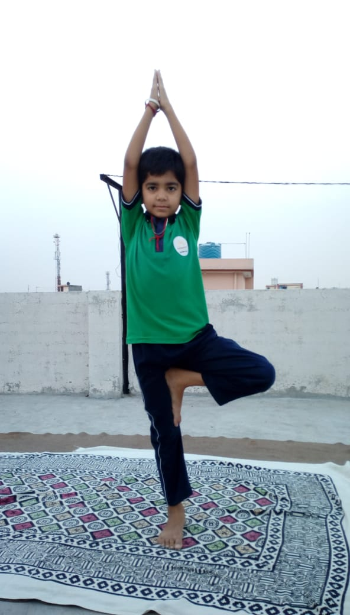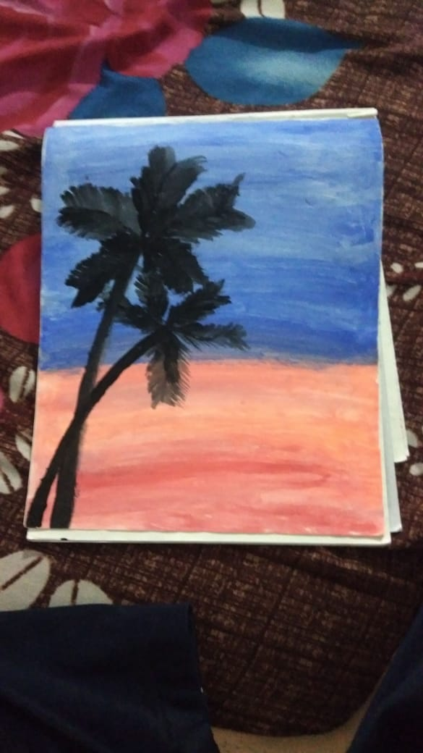
PAPER ACTIVITY

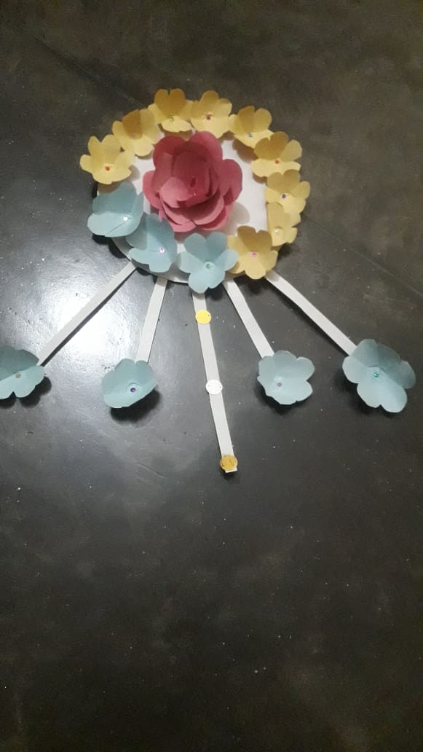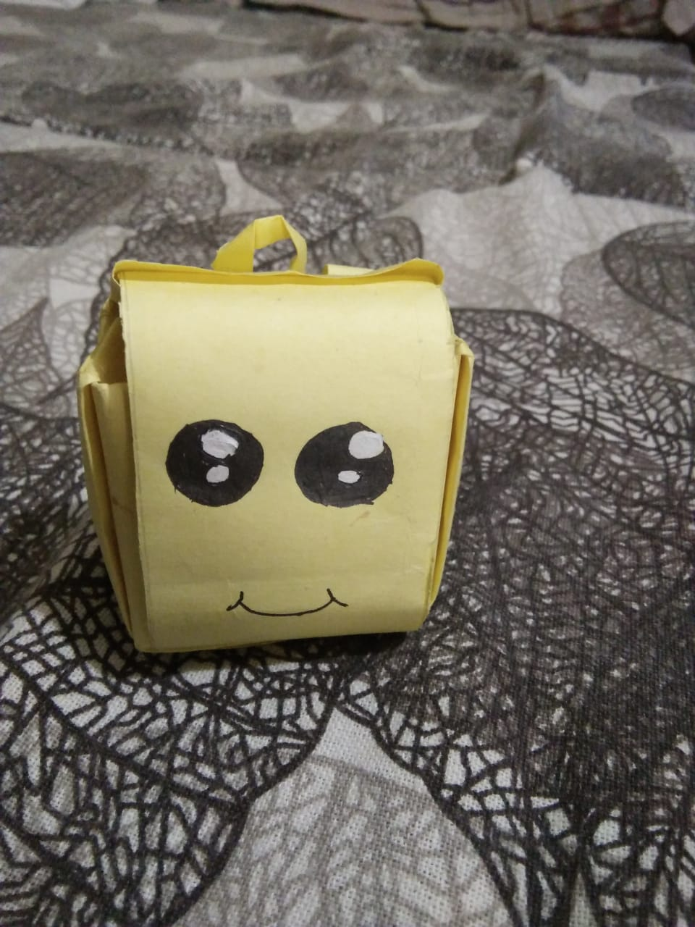

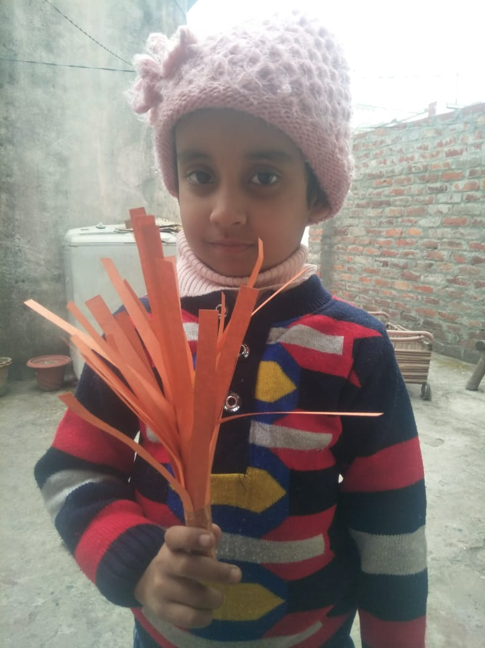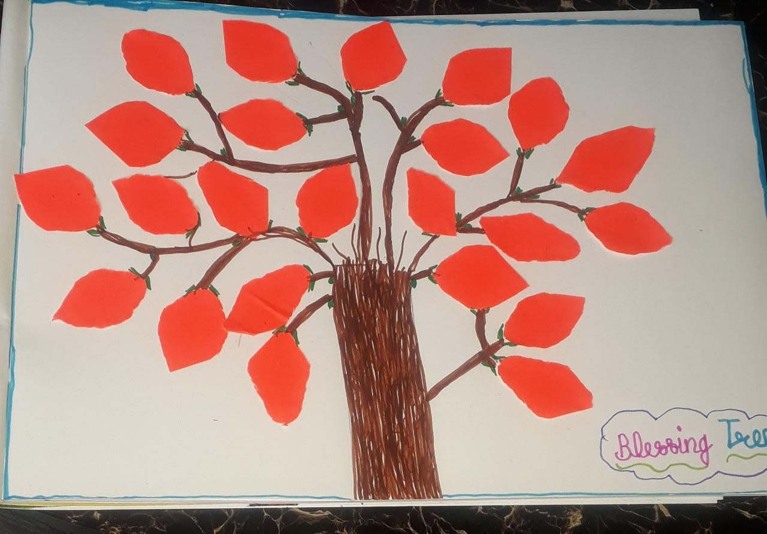
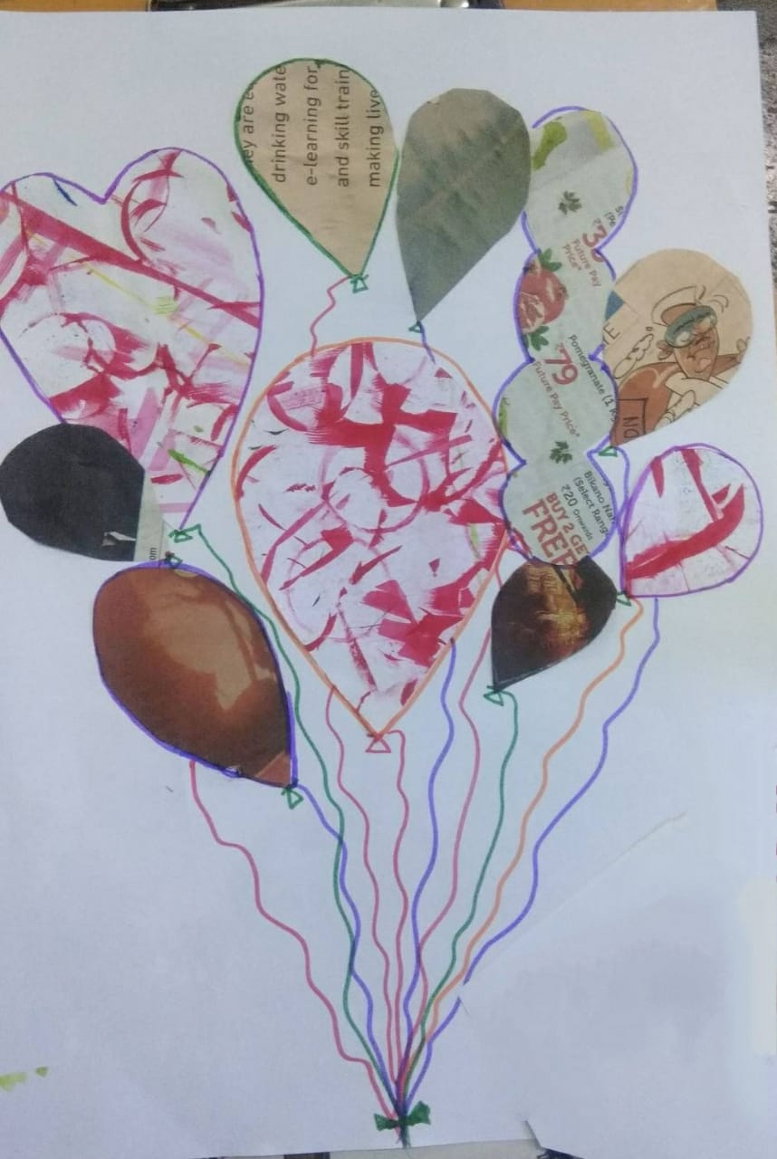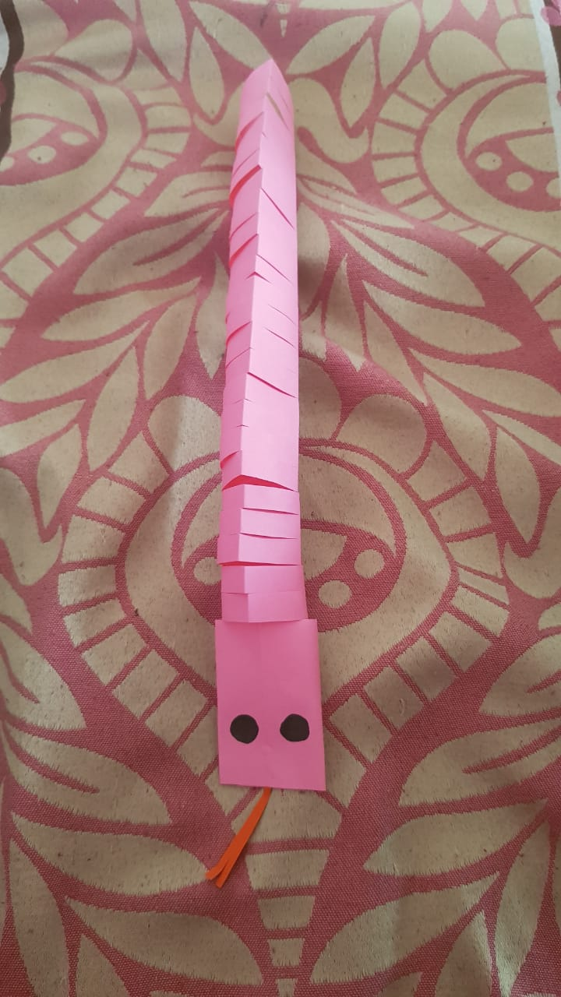

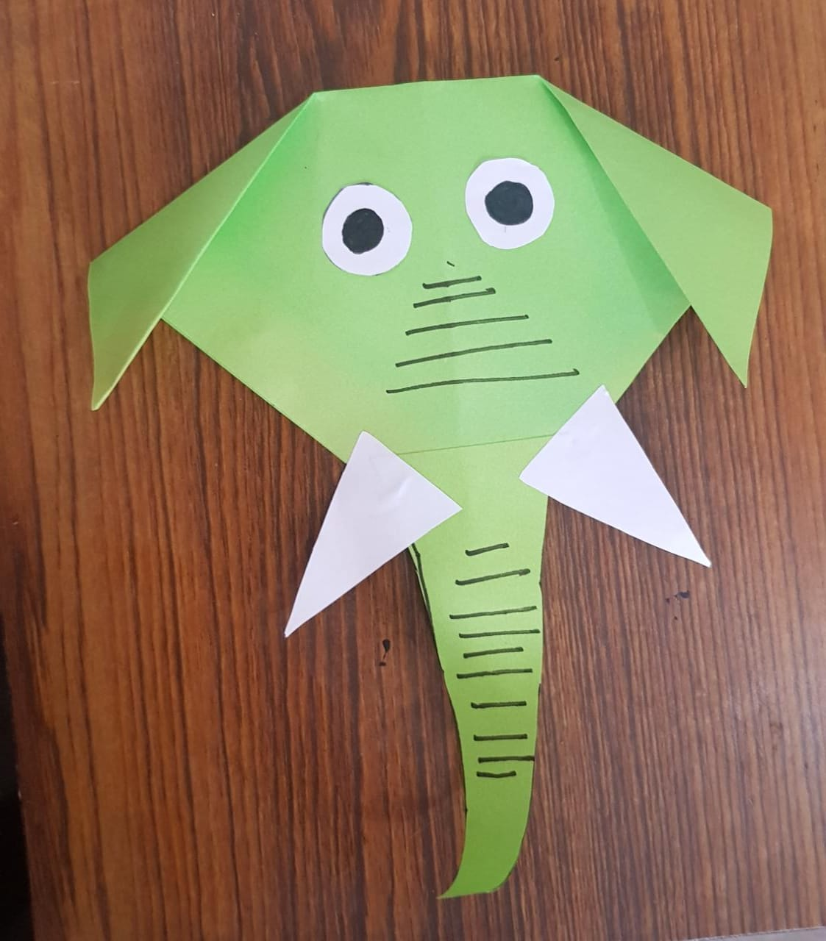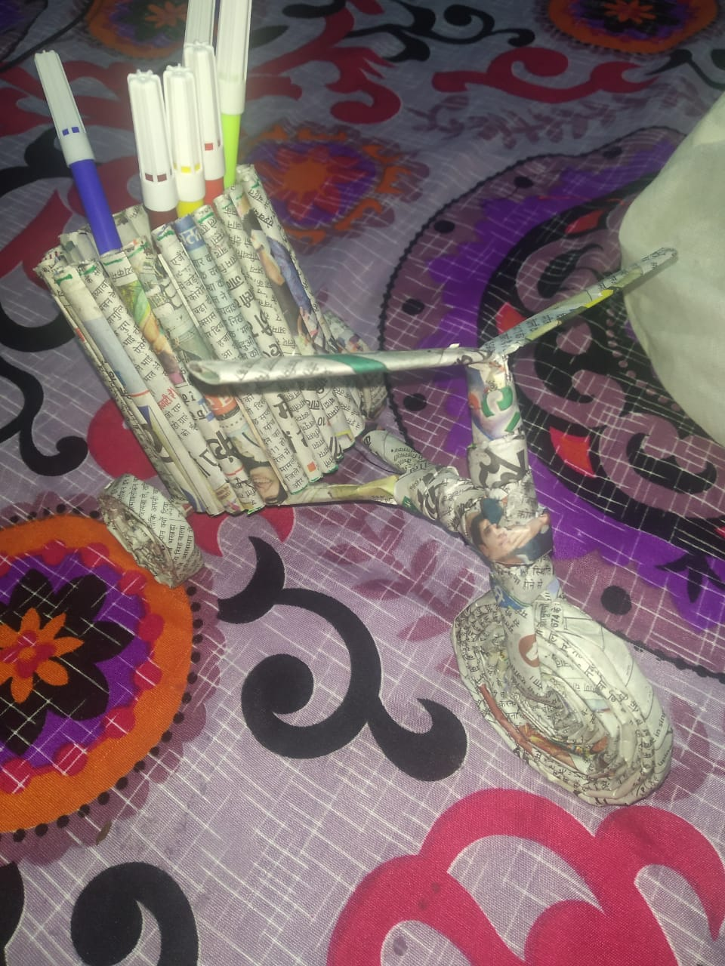
PLOGGING RUN ACTIVITY

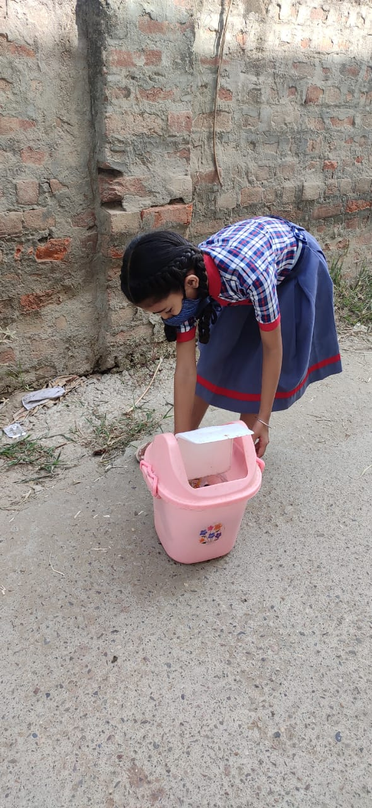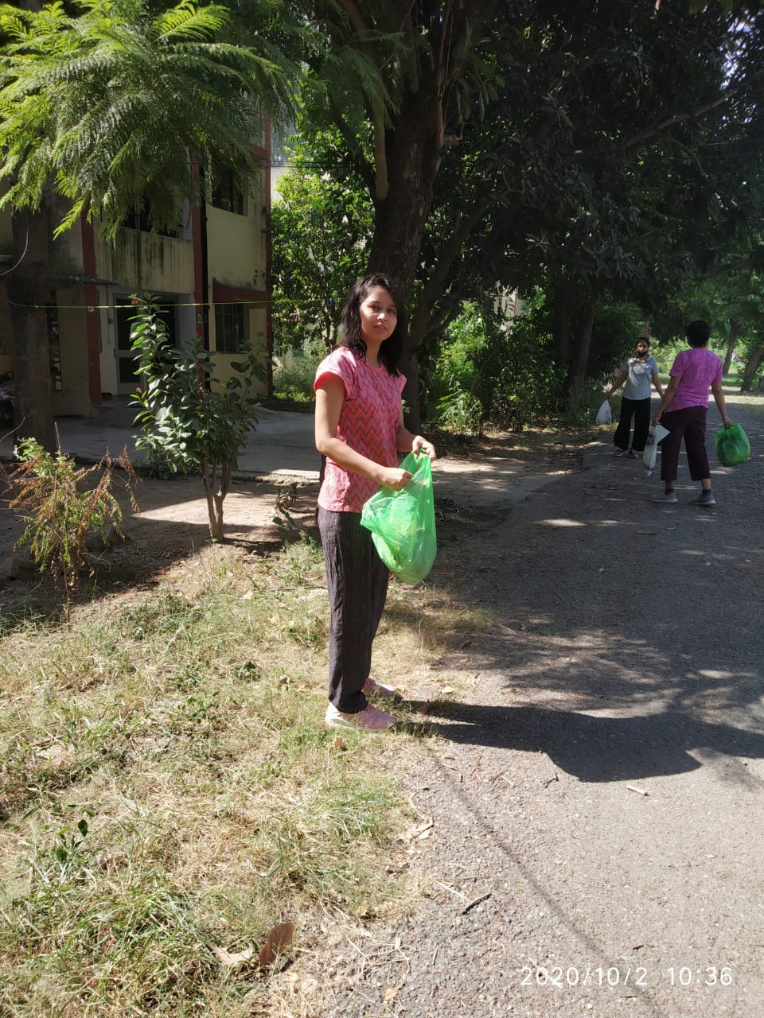

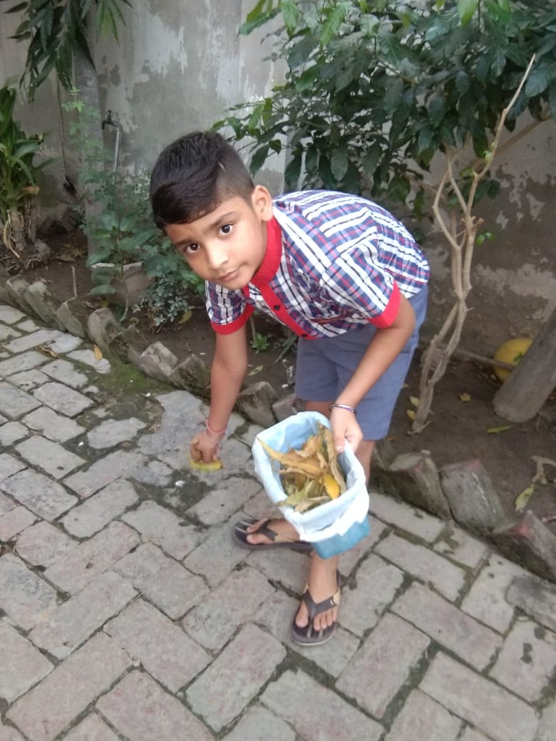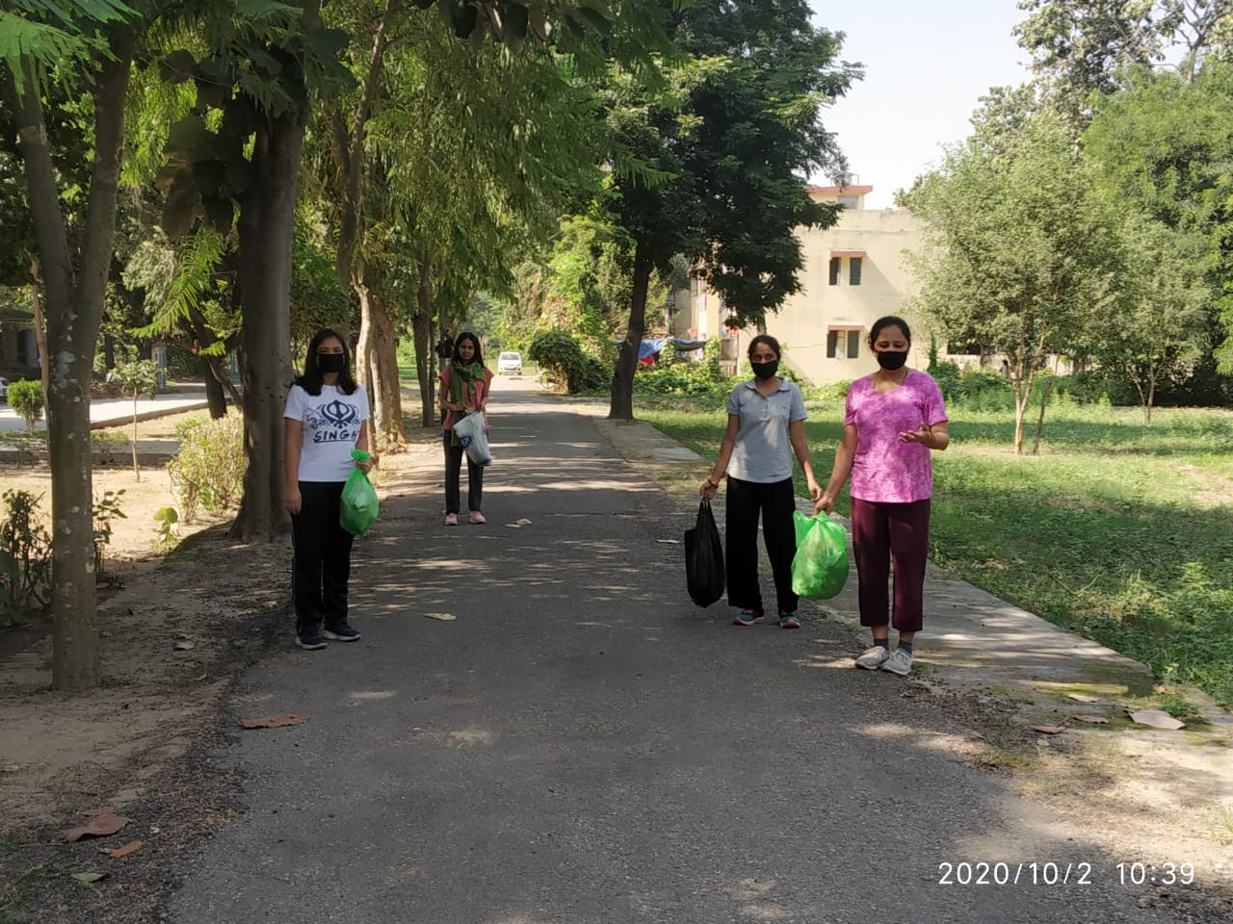
EVS & MATHEMATICS CBL WORKSHOP
OF PRIMARY TEACHERS

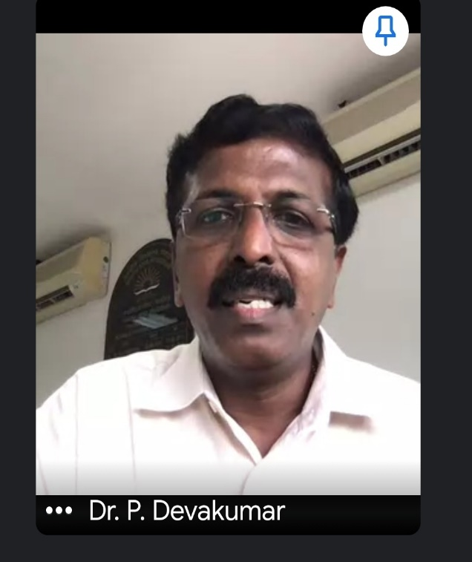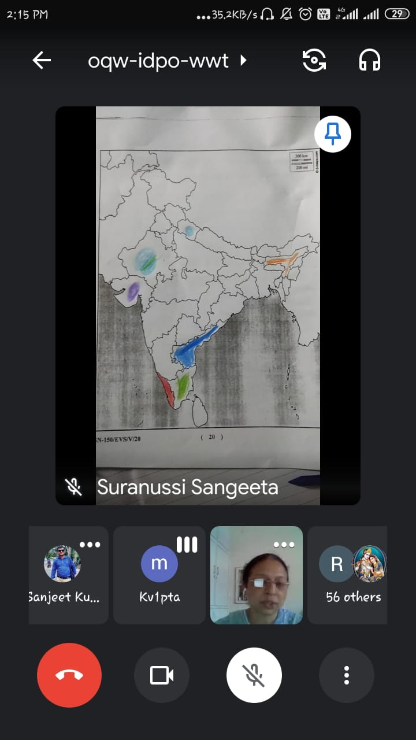

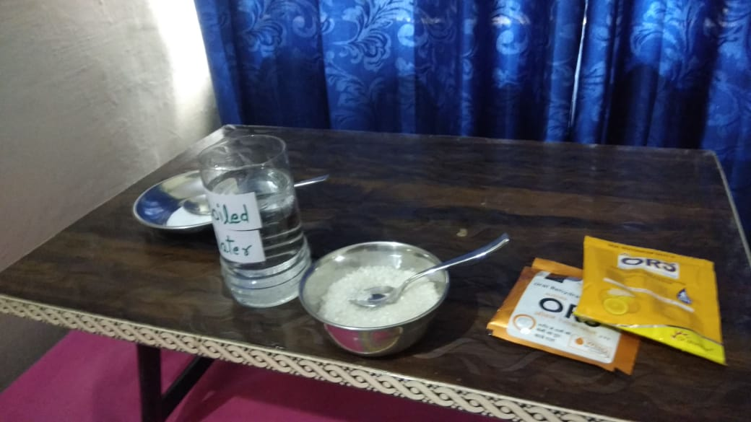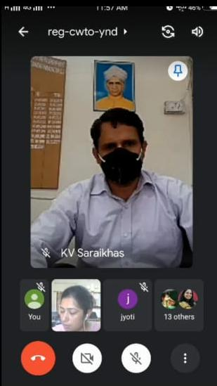
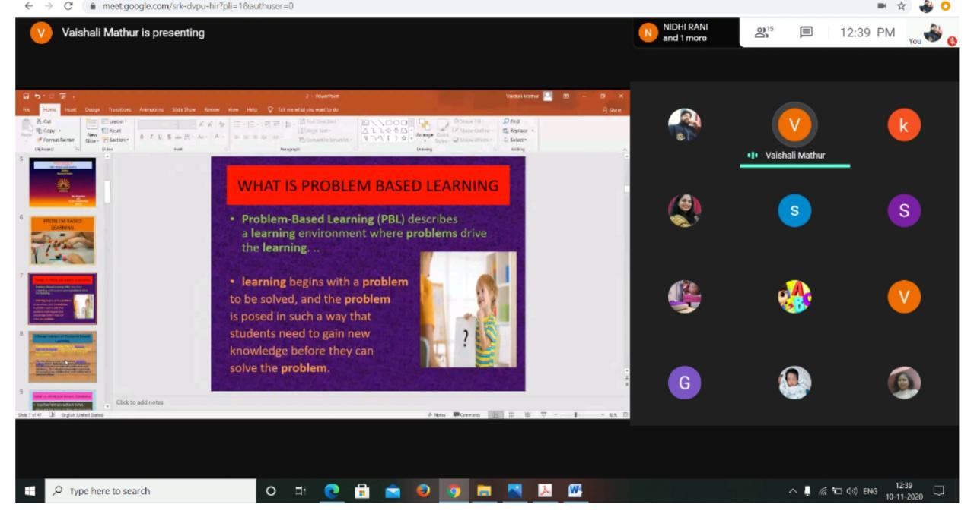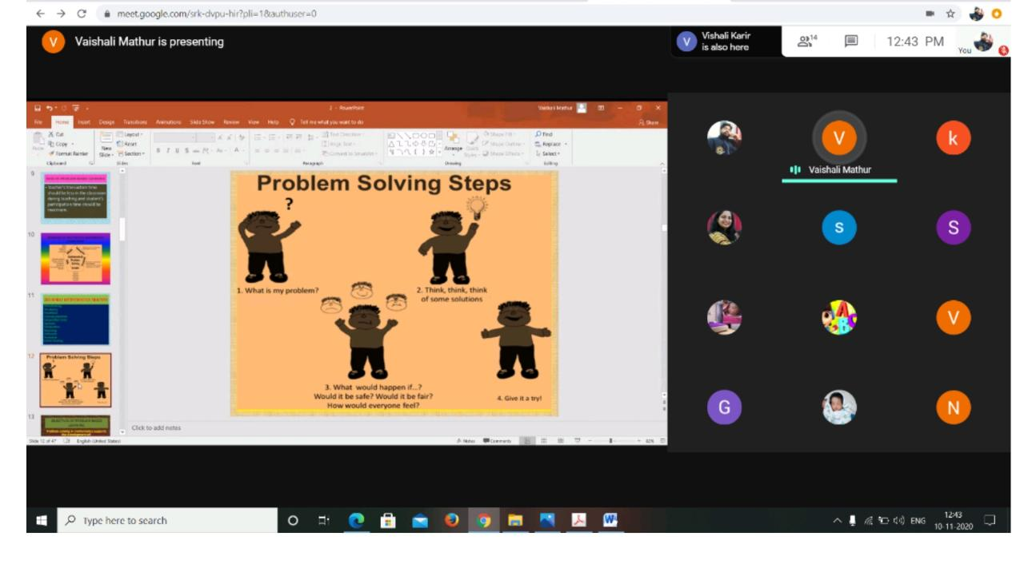

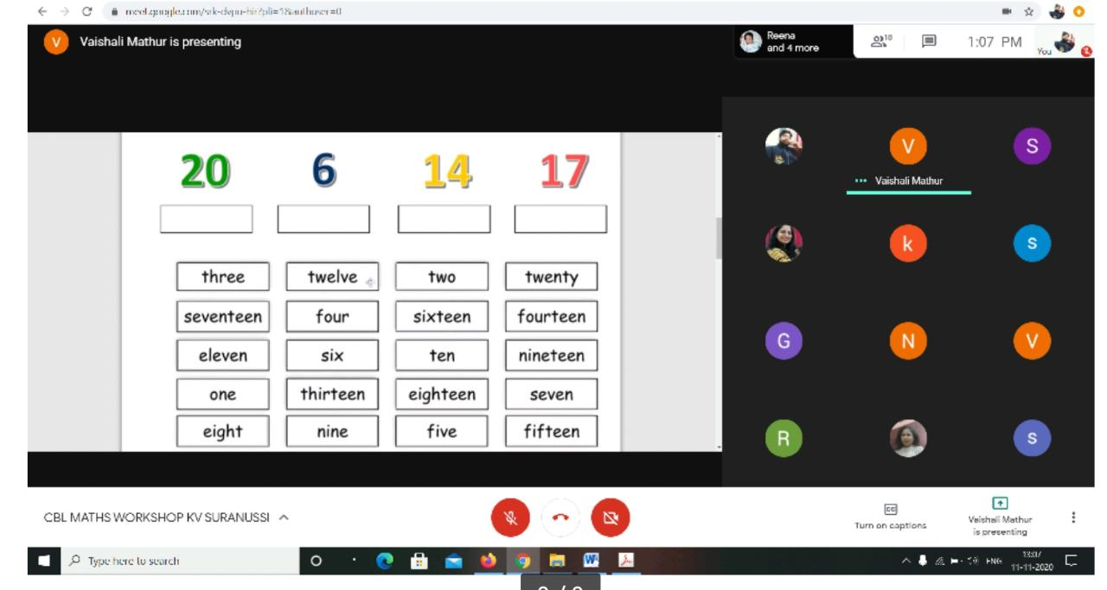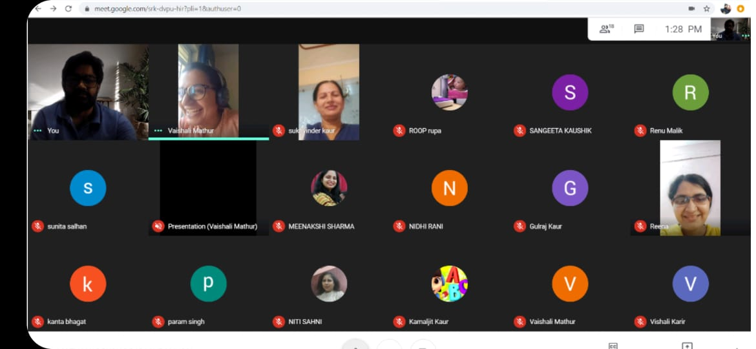
You cannot make children learn, you can only provide the right condition for learning to happen…

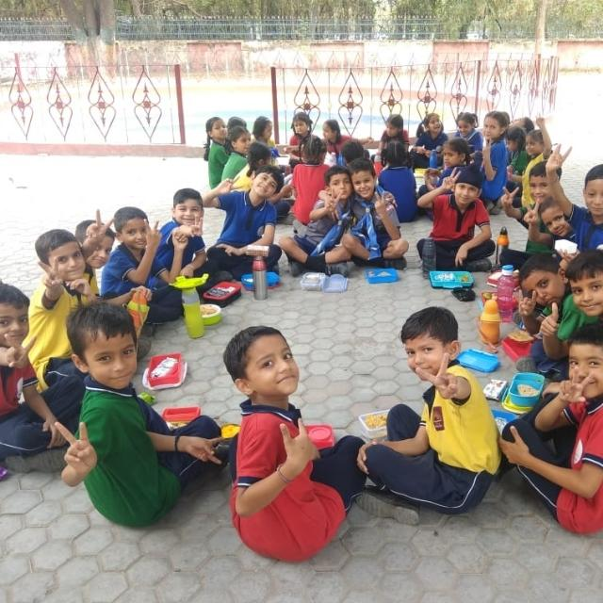

Thank you

